
Department of Computer Science and Engineering
A Project Report On,
“AI DRIVEN HEALTHCARE ADVISER”
A Project Report Submitted to Visvesvaraya Technological University,

BACHELOR OF TECHNOLOGY IN
COMPUTER SCIENCE AND BUSINESS SYSTEMS
Submitted by,

Mahesh Appsaheb Karagaonkar 2VX22CB026


2025-26

Department of Computer Science and Engineering
Certificate of Approval
This is to certify that Mr. Mahesh Appasaheb Karagaonkar (USN:2VX22CB026) have satisfactorily completed the Project Phase-2 Work (Course Code: BCB786) entitled “LLM Based Book Recommendation System.” The project is a Bonafide work carried out by the students of the Department of Computer Science and Engineering, Visvesvaraya Technological University, ‘Jnana Sangama’, Belagavi, in partial fulfillment of the academic requirements for the award of the Bachelor of Technology in Computer Science and Engineering during the academic year 2025-2026.

The Project Phase-2 report has been reviewed and approved as it satisfies the academic standards and requirements prescribed for the said degree.

Guide Project Coordinator Chairperson
Dr. Shanmukhappa A. Angadi

Name of the Examiners Signatures
……………………… ………………………

VISVESVARAYA TECHNOLOGICAL UNIVERSITY
JNANA SANGAMA, BELAGAVI–590018

DEPARTMENT OF COMPUTER SCIENCE AND ENGINEERING

CANDIDATES DECLARATION

ACKNOWLEDGEMENT

ABSTRACT

The rapid advancement of Artificial Intelligence (AI) and Natural Language Processing (NLP) has significantly transformed various domains, including healthcare. Modern healthcare systems increasingly require intelligent, accessible, and real-time solutions to assist users in understanding symptoms, predicting potential diseases, and obtaining preliminary medical guidance. However, traditional healthcare systems often suffer from limitations such as lack of accessibility, delayed consultations, limited personalization, and absence of real-time interaction, particularly for early-stage diagnosis and basic health inquiries.
This project presents an AI Driven Healthcare Adviser, an intelligent web-based system that leverages Large Language Models (LLMs) through Groq API integration to deliver context-aware and personalized healthcare assistance. The system enables users to interact using natural language by providing inputs such as symptoms, medical history, allergies, and general health queries. Based on this information, the AI model analyses the input semantically and generates meaningful responses including possible disease predictions, suggested treatments, and precautionary measures.
The proposed system integrates multiple functional modules to provide a comprehensive healthcare solution. These include an AI-powered chatbot for real-time consultation, a disease prediction module that identifies possible conditions based on symptoms, a treatment plan generator that suggests medicines, diet, and lifestyle changes, an alternative medicine module that recommends herbal and Ayurvedic remedies, a hospital recommendation system for nearby healthcare facilities, and a medical report analysis module that extracts and interprets information from uploaded PDF reports. The backend is implemented using Flask, while the AI reasoning is handled through LLM-based prompt engineering, ensuring accurate and dynamic responses.
Additionally, the system maintains user-specific data such as age, gender, and medical history to enhance personalization and improve the relevance of recommendations. By combining AI intelligence with user-centric design, the system ensures a seamless and interactive experience.

Table of Contents
📖 CHAPTER 1 4
1.1 Background of the Study 4
1.2 Motivation of the Study 5
1.3 Domain and Project-Specific Applications 5
1.3.1 Domain: AI in Healthcare 5
1.3.2 Project-Specific Applications 5
1.4 Overview of the Proposed Solution 6
1.5 Brief Description of Results Obtained 6
1.6 Objectives 7
CHAPTER 2 8
2. PROBLEM STATEMENT 8
📖 CHAPTER 3 9
3. PROPOSED SOLUTION 9
3.1 Proposed Solution 9
3.2 Architecture and Data Flow 9
3.3 System Workflow 9
3.4 Unique Features 9
3.5 Home/Landing Page 10
3.6 User Dashboard 10
3.7 Authentication/Login 10
3.8 Feature Enhancements 10
📖 CHAPTER 4 11
4. SYSTEM DESIGN AND IMPLEMENTATION 11
4.1 Introduction 11
4.2 Functional Requirements 11
4.2.1 User Registration and Authentication 11
4.2.2 Chatbot Consultation Module 11
11
4.2.3 Disease Prediction Module 11
4.2.4 Treatment Plan Generation Module 12
4.2.5 Alternative Medicine Module 12
4.2.6 Hospital Recommendation Module 12
4.2.7 Medical Report Analysis Module 12
4.3 Non-Functional Requirements 13
4.3.1 Performance Requirements 13
4.3.2 Reliability and Availability 13
4.3.3 Security and Privacy 13
4.3.4 Scalability and Maintainability 13
4.4 Hardware Requirements 13
4.5 Software Requirements 13
4.6 Assumptions and Constraints 14
4.7 Conclusion 14
CHAPTER 5 15
5. TOOLS AND TECHNOLOGIES USED 15
5.1 Frontend Technologies (HTML, CSS, JavaScript) 15
5.3 AI Integration (Groq API – Large Language Model) 16
5.4 PDF Processing (PyPDF2) 17
5.5 Development Environment (Visual Studio Code) 17
2. Cloud Deployment 17
CHAPTER 6 19
6. SYSTEM DESIGN 19
6.1 Introduction to System Design 19
6.2 Overall System Architecture 19
6.3 Client-Side Design 20
6.4 Server-Side Design 21
6.5 Data Management Design 21
6.6 AI Processing and Prompt Design 22
6.7 Security and Access Control Design 22
6.8 Scalability and Extensibility Design 22
6.9 System Design Summary 23
CHAPTER 8 24
EXPERIMENTAL ANALYSIS 24
1.1 Introduction to Experimental Analysis 24
CHAPTER 8 25
8. EXPERIMENTAL ANALYSIS 25
8.1 Introduction 25
8.2 Experimental Setup 25
8.3 Testing of Chatbot Module 25
8.4 Testing of Disease Prediction Module 26
8.5 Testing of Treatment Plan Module 26
8.6 Testing of Report Analysis Module 26
8.7 Performance Evaluation 27
8.8 Accuracy and Relevance Analysis 27
8.9 Discussion of Observations 27
8.10 Experimental Analysis Summary 28
CHAPTER 9 29
9. CONCLUSION AND FUTURE WORK 29
9.1 Conclusion 29
9.2 Achievement of Objectives 29
9.3 System Effectiveness 29
9.4 Limitations 30
9.5 Future Enhancements 30
9.6 Scope for Real-World Deployment 30
9.7 Final Remarks 31
REFERENCES 32

📖 CHAPTER 1
1.INTRODUCTION
The rapid advancement of Artificial Intelligence (AI) and Natural Language Processing (NLP) has significantly transformed various industries, particularly the healthcare sector. With the increasing demand for accessible and efficient healthcare services, there is a growing need for intelligent systems that can assist users in understanding their health conditions, predicting diseases, and providing preliminary medical guidance.
The AI Driven Healthcare Adviser is designed to provide intelligent, real-time healthcare assistance by leveraging Large Language Models (LLMs). Unlike traditional healthcare systems that rely on manual consultation or static information, this system enables users to interact using natural language and receive personalized, context-aware responses. Users can input symptoms, medical history, and health-related queries, and the system processes this information to provide disease predictions, treatment suggestions, and precautionary advice.
The system integrates multiple healthcare functionalities such as chatbot consultation, disease prediction, treatment plan generation, alternative medicine suggestions, hospital recommendations, and medical report analysis. By combining AI capabilities with a user-friendly interface, the system enhances accessibility, improves user engagement, and provides quick preliminary insights into health conditions.
Overall, this project demonstrates how AI-driven systems can revolutionize healthcare by offering scalable, efficient, and user-centric solutions for everyday medical assistance.

1.1 Background of the Study
The healthcare sector has been facing several challenges, including increasing patient load, limited availability of medical professionals, and lack of accessibility in rural and remote areas. Many individuals delay seeking medical advice due to time constraints, cost factors, or lack of awareness, which can lead to serious health complications.
At the same time, the internet provides a vast amount of medical information, but users often struggle to find accurate and reliable guidance. Traditional systems based on keyword search or predefined rules fail to understand the actual intent behind user queries, resulting in generic or irrelevant information.
With the development of AI and LLMs, it is now possible to create systems that understand natural language, analyse user input, and provide meaningful and personalized recommendations. These technologies enable smarter healthcare solutions that can assist users in making informed decisions about their health.

1.2 Motivation of the Study
The primary motivation behind this project is to develop an intelligent healthcare system that can provide quick and reliable medical assistance without the need for immediate physical consultation.
Many people face difficulties in identifying symptoms, understanding medical reports, and deciding when to consult a doctor. This project aims to bridge this gap by providing an AI-powered platform that offers instant guidance, reduces dependency on traditional consultation for minor issues, and improves accessibility to healthcare services.
Additionally, the motivation includes:
- Providing personalized healthcare recommendations
- Enabling early detection of potential diseases
- Reducing time and cost associated with basic consultations
- Enhancing user awareness about health conditions

1.3 Domain and Project-Specific Applications

1.3.1 Domain: AI in Healthcare
This project belongs to the domain of Artificial Intelligence in Healthcare, where AI techniques are used to improve diagnosis, treatment, and patient interaction. AI-powered healthcare systems utilize machine learning and natural language processing to analyze medical data, interpret symptoms, and provide decision support.
By integrating LLMs, the system can understand complex user queries and generate context-aware responses, making healthcare assistance more efficient and user-friendly.

1.3.2 Project-Specific Applications
The AI Driven Healthcare Adviser can be applied in various real-world scenarios, including:

Providing personalized healthcare assistance to users
- Predicting diseases based on symptoms
- Assisting users in understanding medical reports
- Supporting telemedicine and online consultation platforms
- Suggesting treatment plans and lifestyle improvements
- Recommending nearby hospitals and pharmacies

1.4 Overview of the Proposed Solution
The proposed system is a web-based healthcare platform that provides intelligent assistance using AI. Users can interact with the system through natural language by entering their symptoms, medical history, or health-related queries.
The system processes the input using a Large Language Model integrated through the Groq API and generates meaningful responses. It includes several modules such as:
- Chatbot for real-time consultation
- Disease prediction module
- Treatment plan generator
- Alternative medicine suggestion module
- Hospital recommendation system
- Medical report analysis module
The backend is implemented using Flask, ensuring efficient request handling and seamless integration with AI services.

1.5 Brief Description of Results Obtained
The developed system successfully provides accurate and context-aware healthcare recommendations based on user input. The chatbot module effectively understands natural language queries and generates relevant responses.
The disease prediction module identifies possible conditions based on symptoms, while the treatment module suggests medicines, diet plans, and lifestyle changes. The report analysis feature extracts key insights from medical reports, and the hospital recommendation module provides useful location-based suggestions.
Overall, the system demonstrates fast response time, improved personalization, and a user-friendly experience.

1.6 Objectives
The main objectives of the AI Driven Healthcare Adviser are:
- To develop an AI-based healthcare system using natural language input
- To predict diseases based on user symptoms
- To generate personalized treatment plans including medicines, diet, and lifestyle changes
- To provide alternative medicine suggestions such as herbal and Ayurvedic remedies
- To recommend nearby hospitals and pharmacies
- To analyze medical reports and extract useful insights
- To improve accessibility and efficiency in healthcare services
- To design a scalable and user-friendly system

CHAPTER 2

2. PROBLEM STATEMENT

In today’s fast-paced world, access to timely and reliable healthcare remains a significant challenge. Many individuals face difficulties in consulting medical professionals due to factors such as time constraints, high costs, limited availability of doctors, and geographical barriers. As a result, people often ignore early symptoms or rely on unreliable sources of information, which may lead to serious health complications.
Traditional healthcare systems primarily depend on physical consultations and manual diagnosis, which can be time-consuming and inefficient for minor health concerns. Additionally, existing online healthcare platforms often provide generic information based on keyword searches, without understanding the actual context or intent behind user queries.
Another major challenge is the lack of systems that can:
- Analyze symptoms in real time
- Provide personalized recommendations
- Interpret medical reports automatically
- Suggest nearby healthcare facilities
Users also struggle to understand complex medical reports and terminology, making it difficult for them to take appropriate actions.
Therefore, there is a need for an intelligent, AI-driven healthcare system that can:
- Understand user queries in natural language
- Provide context-aware and personalized medical advice
- Predict possible diseases based on symptoms
- Generate treatment suggestions and preventive measures
- Improve accessibility and efficiency in healthcare services
The proposed system aims to address these challenges by leveraging AI and Large Language Models to deliver a smart, interactive, and user-friendly healthcare solution.

📖 CHAPTER 3

3. PROPOSED SOLUTION

3.1 Proposed Solution
The proposed system, AI Driven Healthcare Adviser, is a web-based platform designed to provide intelligent healthcare assistance using Artificial Intelligence. It enables users to interact with the system using natural language and receive personalized medical guidance.
The system integrates multiple modules such as chatbot consultation, disease prediction, treatment plan generation, alternative medicine suggestions, hospital recommendations, and medical report analysis. By utilizing Large Language Models (LLMs), the system can understand user input semantically and generate meaningful responses.

3.2 Architecture and Data Flow
The system follows a client-server architecture where the frontend interacts with the backend through HTTP requests.
- The user inputs data such as symptoms or queries through the interface
- The backend (Flask) processes the request
- The input is sent to the Groq API (LLM)
- The AI model analyzes the data and generates a response
- The response is returned to the frontend and displayed to the user
This flow ensures real-time, accurate, and personalized healthcare assistance.

3.3 System Workflow
- User registers and logs into the system
- User enters symptoms or queries
- The system collects user data (age, gender, medical history)
- Input is processed using AI model
- System generates response (prediction/treatment/advice)
- Results are displayed to the user

3.4 Unique Features
- AI-powered chatbot for real-time consultation
- Disease prediction based on symptoms

- Personalized treatment plans
- Alternative medicine suggestions (Ayurveda, herbal)
- Hospital and pharmacy recommendations
- Medical report analysis from PDF files
- Context-aware responses using user data

3.5 Home/Landing Page
The home page provides an overview of the system and its features. It includes a simple and user-friendly interface with options for registration, login, and accessing healthcare services. The design focuses on ease of use and accessibility.

3.6 User Dashboard
The user dashboard allows users to access different modules of the system. It displays options such as chatbot consultation, disease prediction, treatment plan generation, report analysis, and hospital recommendations. It provides a centralized interface for all functionalities.

3.7 Authentication/Login
The system includes a secure authentication mechanism that allows users to register and log in using their details. User data is stored in sessions to provide personalized recommendations. Proper validation and error handling ensure secure access.

3.8 Feature Enhancements
Future enhancements may include:
- Voice-based interaction
- Integration with real hospital databases
- Mobile application support
- Real-time health monitoring using wearable devices
- Multilingual support

📖 CHAPTER 4

4. SYSTEM DESIGN AND IMPLEMENTATION

4.1 Introduction
This chapter describes the overall design and implementation of the AI Driven Healthcare Adviser system. It explains how different modules are structured and how they interact to provide intelligent healthcare assistance. The system is designed using a modular architecture to ensure scalability, maintainability, and efficient performance.
The implementation combines a web-based interface with backend processing and AI integration. The frontend handles user interaction, while the backend processes user input and communicates with the AI model to generate responses. The system is designed to provide real-time, accurate, and personalized healthcare recommendations.

4.2 Functional Requirements
Functional requirements define the core features and operations that the system must perform to meet user needs.

4.2.1 User Registration and Authentication
The system provides a secure mechanism for users to register and log in. During registration, users enter details such as age, gender, medical history, and allergies. This information is stored and used to provide personalized recommendations.
Authentication ensures that only authorized users can access the system. Session management is used to maintain user data during interaction. The system also validates user inputs and handles errors for invalid or missing information.

4.2.2 Chatbot Consultation Module
The chatbot module allows users to interact with the system using natural language. Users can ask health-related questions, describe symptoms, or seek advice.
The system processes the query using an AI model and generates meaningful responses. The chatbot provides short, clear, and helpful medical suggestions while encouraging users to consult a doctor when necessary.

4.2.3 Disease Prediction Module
This module enables users to input symptoms and receive possible disease predictions. The system analyzes the symptoms using AI and provides a list of potential diseases along with explanations.
It helps users understand their condition at an early stage and guides them toward appropriate actions.

4.2.4 Treatment Plan Generation Module
This module generates a structured treatment plan based on the identified condition. The output includes:
- Suggested medicines
- Dietary recommendations
- Lifestyle changes
- Precautionary measures
The treatment plan is designed to provide general guidance and improve user awareness about managing health conditions.

4.2.5 Alternative Medicine Module
This module provides suggestions for natural and alternative treatments. It includes:
- Herbal remedies
- Ayurvedic treatments
- Diet-based solutions
This feature helps users explore non-conventional healthcare options and supports holistic wellness.

4.2.6 Hospital Recommendation Module
The hospital recommendation module suggests nearby hospitals and pharmacies based on the user’s location. It provides relevant details such as:
- Hospital names
- Specialties
- Approximate distance
- Contact information (if available)
This feature improves accessibility to healthcare services.

4.2.7 Medical Report Analysis Module
This module allows users to upload medical reports in PDF format. The system extracts text from the document and analyzes it using AI.
The output includes:
- Summary of findings
- Identification of abnormalities
- Recommendations
This helps users understand complex medical reports easily.

4.3 Non-Functional Requirements
Non-functional requirements define the quality attributes of the system.

4.3.1 Performance Requirements
The system must provide fast and efficient responses to user queries. AI processing, API calls, and data handling should be optimized to minimize response time. The system should also handle multiple users simultaneously without performance degradation.

4.3.2 Reliability and Availability
The system should be reliable and available at all times. It must handle errors gracefully and ensure continuous operation. Proper error handling and fallback mechanisms should be implemented to avoid system failures.

4.3.3 Security and Privacy
User data such as personal details and medical history must be protected. The system uses authentication mechanisms and secure session handling to prevent unauthorized access.
Sensitive data should be handled securely, and user privacy must be maintained at all times.

4.3.4 Scalability and Maintainability
The system is designed to support future growth in terms of users and features. A modular architecture allows easy addition of new functionalities.
Maintainability is ensured through clean code structure, proper documentation, and reusable components.

4.4 Hardware Requirements
The system requires the following hardware:
- Processor: Intel i5 or higher
- RAM: Minimum 8 GB
- Storage: Minimum 256 GB
- Internet connection for API access

4.5 Software Requirements
The system requires the following software:
- Python (programming language)
- Flask (backend framework)
- Groq API (AI model integration)
- PyPDF2 (PDF processing)
- Web browser (for accessing the system)

4.6 Assumptions and Constraints
Assumptions:
- Users have access to internet and web browser
- Users provide accurate medical information
- API services are available and functional
Constraints:
- AI responses may not replace professional medical advice
- System depends on external API performance
- Limited real-time medical database integration

4.7 Conclusion
The system design and implementation provide a robust framework for delivering intelligent healthcare assistance. By integrating multiple modules with AI capabilities, the system ensures efficient processing, personalized recommendations, and a user-friendly experience.
The modular architecture and scalable design allow the system to evolve with future enhancements, making it suitable for real-world healthcare applications.

CHAPTER 5

5. TOOLS AND TECHNOLOGIES USED
This chapter explains the tools, technologies, frameworks, and libraries used in the development of the AI Driven Healthcare Adviser system. These technologies are carefully selected to ensure efficient system performance, scalability, real-time interaction, and seamless integration of Artificial Intelligence capabilities.
The system follows a full-stack architecture, where the frontend handles user interaction, the backend processes requests, and the AI layer provides intelligent decision-making.

5.1 Frontend Technologies (HTML, CSS, JavaScript)
The frontend is responsible for user interaction and presentation of results. It is developed using HTML, CSS, and JavaScript, which together create a responsive and interactive user interface.
- HTML (HyperText Markup Language)
HTML forms the backbone of the frontend by structuring web pages. It is used to create elements such as:
  - Input forms for symptoms and queries
  - Buttons for actions like prediction and analysis
  - Sections for displaying results
- CSS (Cascading Style Sheets)
CSS enhances the visual appearance of the application. It is used for:
  - Designing layouts and page structure
  - Styling buttons, forms, and cards
  - Making the interface responsive across devices
- JavaScript
JavaScript adds interactivity and dynamic behavior to the system. It is used to:
  - Handle user input and form validation
  - Send requests to the backend using AJAX/Fetch API
  - Display results dynamically without refreshing the page
Overall, the frontend ensures a smooth and user-friendly experience, allowing users to easily interact with the system.

5.2 Backend Technologies (Python, Flask)
The backend is responsible for processing user requests, managing application logic, and integrating AI services.
- Python
Python is used as the primary programming language due to its:
  - Simplicity and readability
  - Strong ecosystem for AI and data processing
  - Easy integration with APIs and libraries
- Flask Framework
Flask is a lightweight and flexible web framework used for backend development. It provides:
  - Routing mechanisms to handle different URLs (e.g., chatbot, prediction, report analysis)
  - Request handling (GET and POST methods)
  - Integration with AI APIs and external services
  - Session management for storing user data
Flask acts as the central controller that connects the frontend with the AI model and ensures smooth communication between different modules.

5.3 AI Integration (Groq API – Large Language Model)
The core intelligence of the system is powered by Large Language Models (LLMs) integrated through the Groq API.
LLMs are advanced AI models capable of understanding and generating human-like text based on input data. In this system, the AI model is used for:
- Interpreting user queries in natural language
- Analyzing symptoms and predicting diseases
- Generating treatment plans with structured recommendations
- Providing medical advice and precautions
- Summarizing and analyzing medical reports
The system uses prompt engineering, where user inputs (symptoms, history, etc.) are structured into meaningful prompts before sending them to the AI model. This ensures accurate and context-aware responses.
The use of LLMs allows the system to:
- Go beyond keyword-based responses
- Understand user intent

- Provide personalized and intelligent outputs

5.4 PDF Processing (PyPDF2)
The PyPDF2 library is used for handling and processing PDF files uploaded by users.
This module plays an important role in the medical report analysis feature, where:
- Users upload their medical reports in PDF format
- PyPDF2 extracts textual content from the document
- The extracted text is passed to the AI model
- The system generates insights such as:
  - Summary of findings
  - Detection of abnormalities
  - Recommendations for further action
This feature simplifies complex medical information and helps users understand their reports easily without requiring medical expertise.

5.5 Development Environment (Visual Studio Code)
The development of the project is carried out using Visual Studio Code (VS Code), a widely used code editor.
Key features include:
- Syntax highlighting for better readability
- Debugging tools for error detection
- Extensions for Python, Flask, and web development
- Integrated terminal for running the application
- Version control support (Git integration)
VS Code provides a flexible and efficient environment for developing, testing, and maintaining the project.

5.6 Deployment Environment
The deployment environment refers to the platform where the system is hosted and made accessible to users.
The system can be deployed in two ways:
1. Local Deployment
- Used during development and testing
- Runs on a local machine using Flask server
- Accessible via browser (localhost)

2. Cloud Deployment
- Used for real-world usage
- Can be deployed on platforms such as:
  - AWS (Amazon Web Services)
  - Heroku
  - Render
Cloud deployment offers:
- High availability
- Scalability
- Remote access from anywhere
Deployment ensures that users can access the system in real time and interact with the AI-powered healthcare adviser seamlessly.

CHAPTER 6

6. SYSTEM DESIGN

6.1 Introduction to System Design
System design defines the structure, components, and interactions of the AI Driven Healthcare Adviser. It provides a blueprint for how the system operates and ensures that all modules work together efficiently.
The design focuses on:
- Scalability (support more users)
- Maintainability (easy updates)
- Performance (fast response)
- Security (protect user data)
The system follows a client-server architecture, where the frontend handles user interaction and the backend processes requests using AI.

6.2 Overall System Architecture
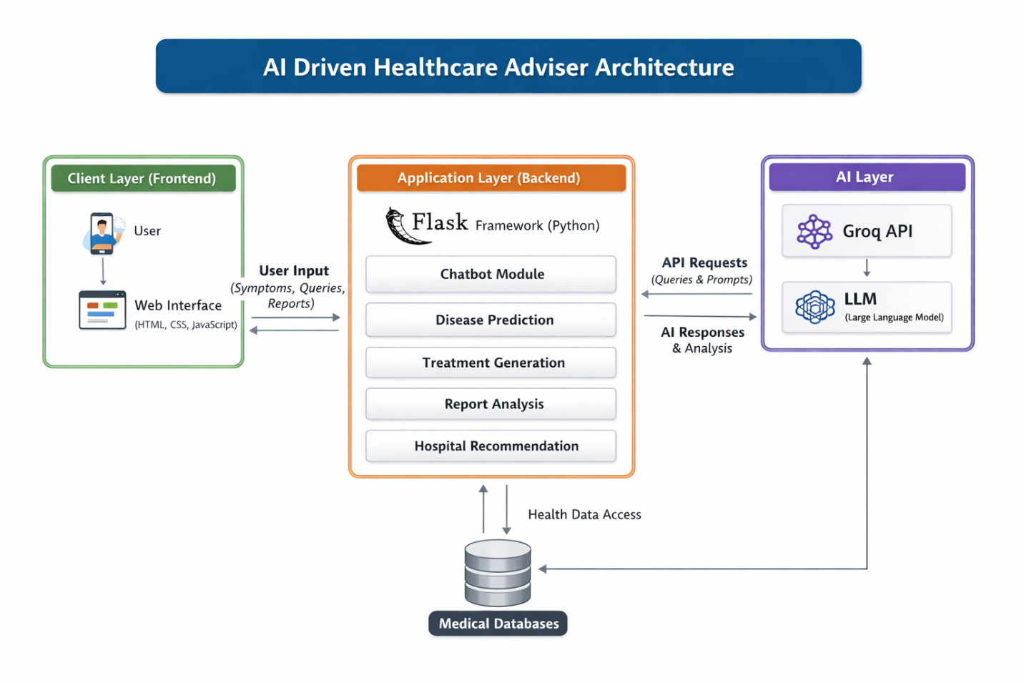
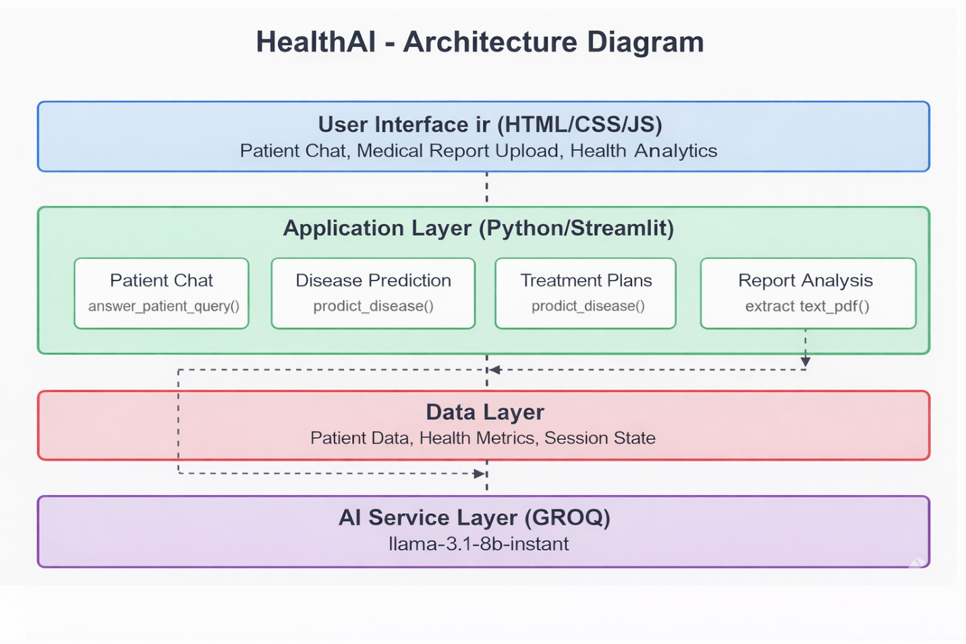
The overall architecture of the system consists of three main layers:
- Client Layer (Frontend)
  - User interface (HTML, CSS, JavaScript)
  - Handles user input and displays results
- Application Layer (Backend - Flask)
  - Processes requests
  - Manages sessions and routing
  - Communicates with AI model
- AI Layer (Groq API - LLM)
  - Performs analysis and generates responses
  - Handles reasoning and predictions
🔹 Architecture Flow:
User → Frontend → Flask Backend → Groq API → Response → Frontend
This layered architecture ensures modularity and efficient processing.
👉 (Insert Architecture Diagram here in Word)

6.3 Client-Side Design
The client-side is responsible for user interaction and interface design.
Key Components:
- Input forms (symptoms, queries, reports)
- Dashboard for accessing modules
- Result display sections
Features:
- User-friendly interface
- Responsive design
- Dynamic updates using JavaScript
The frontend sends user data to the backend and displays AI-generated responses in real time.

6.4 Server-Side Design
The server-side is implemented using Flask and acts as the core processing unit of the system.
Responsibilities:
- Handling HTTP requests (GET, POST)
- Managing routes for different modules
- Processing user inputs
- Communicating with Groq API
- Returning responses to frontend
Key Routes:
- /chat → chatbot
- /predict-disease → disease prediction
- /generate-treatment → treatment plan
- /analyze-report → report analysis
The backend ensures smooth communication between frontend and AI model.

6.5 Data Management Design
The system manages user data using session storage.
Data Stored:
- Age
- Gender
- Medical history
- Allergies
This data is used to personalize responses and improve recommendation accuracy.
Features:
- Temporary storage using sessions
- Secure handling of user data
- No permanent database required (lightweight design)

6.6 AI Processing and Prompt Design
The AI module is responsible for generating intelligent responses using LLM.
Process:
- User input is collected
- Input is structured into a prompt
- Prompt is sent to Groq API
- AI generates response
- Response is returned to user
Example Prompt:
- Symptoms → disease prediction
- Disease → treatment plan
- Report → analysis
Prompt design ensures:
- Context-aware responses
- Accurate outputs
- Personalized suggestions

6.7 Security and Access Control Design
Security is an important aspect of the system.
Security Features:
- User authentication using sessions
- Input validation to prevent errors
- Controlled access to modules
- Secure handling of personal data
The system ensures that only authenticated users can access personalized features.

6.8 Scalability and Extensibility Design
The system is designed to support future growth and enhancements.
Scalability:
- Can handle multiple users
- Cloud deployment support
- Efficient API handling
Extensibility:
- Easy to add new modules
- Can integrate real hospital APIs
- Supports future AI upgrades
This design ensures the system remains flexible and future-ready.

6.9 System Design Summary
The system design integrates frontend, backend, and AI modules into a unified architecture. The client-server model ensures efficient communication, while the AI layer provides intelligent decision-making.
The modular structure allows easy maintenance, scalability, and future enhancements. Overall, the design ensures a reliable, secure, and user-friendly healthcare system.

CHAPTER 8

EXPERIMENTAL ANALYSIS

Introduction to Experimental Analysis
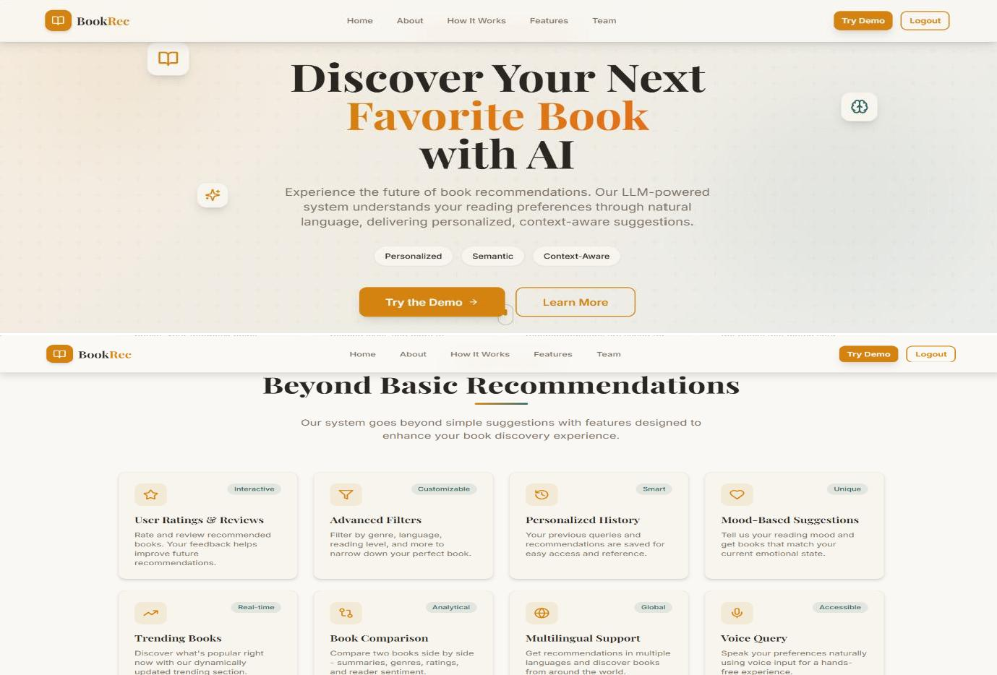
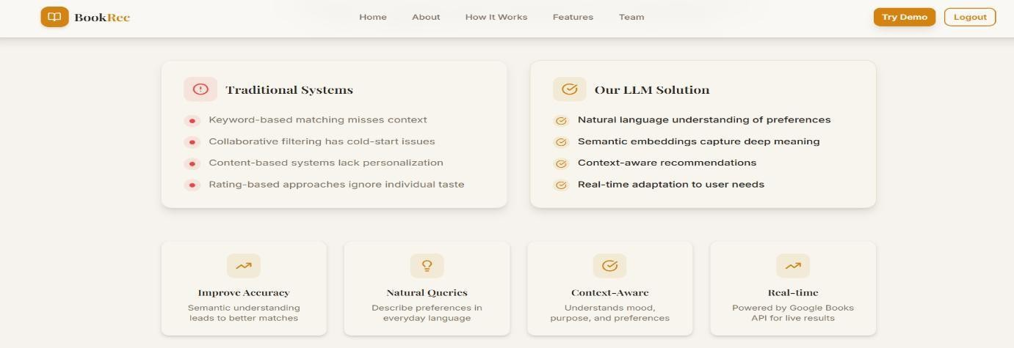

Figure 8.1: Main Homepage of the LLM Based Book Recommendation System

CHAPTER 8

8. EXPERIMENTAL ANALYSIS

8.1 Introduction
This chapter presents the experimental evaluation of the AI Driven Healthcare Adviser system. The purpose of this analysis is to test the system’s functionality, performance, accuracy, and usability under different scenarios.
Various modules of the system, including chatbot consultation, disease prediction, treatment generation, and report analysis, were tested using different user inputs. The system was evaluated based on response accuracy, speed, and user experience.

8.2 Experimental Setup
The system was tested in a controlled environment using the following setup:
- Hardware:
  - Processor: Intel i5
  - RAM: 8 GB
  - Storage: 256 GB
- Software:
  - Operating System: Windows
  - Backend: Flask (Python)
  - AI Model: Groq API (LLM)
  - Browser: Chrome
- Network:
  - Stable internet connection for API communication
The application was run locally using a Flask server and accessed through a web browser.

8.3 Testing of Chatbot Module
The chatbot module was tested using various health-related queries such as symptoms, general medical questions, and advice requests.
Observations:
- The chatbot successfully understood natural language input
- It generated clear and relevant responses
- Responses were context-aware based on user data
Example:
- Input: “I have fever and headache”
- Output: Suggested possible causes and advised rest/consultation

8.4 Testing of Disease Prediction Module
The disease prediction module was evaluated using different symptom combinations.
Observations:
- The system correctly identified possible diseases
- Provided top 2–3 predictions with explanations
- Helped users understand potential health conditions
Example:
- Input: “Fever, cough, fatigue”
- Output: Flu, Viral infection, COVID-like symptoms

8.5 Testing of Treatment Plan Module
The treatment module was tested for different diseases and conditions.
Observations:
- Generated structured treatment plans
- Included medicines, diet, and lifestyle suggestions
- Provided precautionary measures
Output Structure:
- Medicines
- Diet plan
- Lifestyle changes
- Precautions

8.6 Testing of Report Analysis Module
This module was tested by uploading medical reports in PDF format.
Observations:
- Successfully extracted text using PyPDF2
- AI analyzed report content effectively
- Generated summary and recommendations
Example Output:
- Summary of report
- Identified abnormalities
- Suggested next steps

8.7 Performance Evaluation
The system performance was evaluated based on response time and efficiency.
Results:
- Average response time: 2–5 seconds
- Smooth handling of multiple queries
- No significant delays observed
The system maintained stable performance during testing.

8.8 Accuracy and Relevance Analysis
The accuracy of the system was evaluated based on how relevant the responses were to user inputs.
Observations:
- High accuracy in general health queries
- Relevant disease predictions based on symptoms
- Personalized responses using user data
Limitation:
- AI responses are approximate and not 100% medically certified

8.9 Discussion of Observations
From the experiments, it is observed that:
- The system provides fast and intelligent responses
- AI effectively understands natural language
- Modules work seamlessly together
- User experience is smooth and interactive
However, the system depends on AI and external API performance, which may affect accuracy in complex medical cases.

8.10 Experimental Analysis Summary
The experimental analysis confirms that the AI Driven Healthcare Adviser performs efficiently across all modules. It successfully provides personalized healthcare guidance, disease predictions, treatment suggestions, and report analysis.
The system demonstrates:
- Good performance
- High usability
- Reliable AI-based responses
Overall, the system meets the project objectives and proves to be a practical solution for digital healthcare assistance.
.

CHAPTER 9

9. CONCLUSION AND FUTURE WORK

9.1 Conclusion
The AI Driven Healthcare Adviser successfully demonstrates the application of Artificial Intelligence and Large Language Models in the healthcare domain. The system provides an intelligent, interactive, and user-friendly platform that assists users in understanding their health conditions, predicting possible diseases, and receiving preliminary medical guidance.
By integrating multiple modules such as chatbot consultation, disease prediction, treatment plan generation, alternative medicine suggestions, hospital recommendations, and medical report analysis, the system delivers a comprehensive healthcare solution. The use of natural language processing enables users to interact with the system easily, without requiring technical knowledge.
The system achieves its primary goal of improving accessibility to healthcare guidance by providing real-time responses and personalized recommendations. It reduces dependency on immediate physical consultations for minor health concerns and helps users make informed decisions about their health.
Overall, the project highlights the potential of AI-driven systems in transforming traditional healthcare services into more efficient, scalable, and user-centric solutions.

9.2 Achievement of Objectives
The project successfully meets the objectives defined in the initial stages:
- Developed an AI-based healthcare system using natural language input
- Implemented disease prediction based on symptoms
- Generated personalized treatment plans including medicines, diet, and lifestyle changes
- Provided alternative medicine suggestions
- Enabled hospital and pharmacy recommendations
- Implemented medical report analysis using PDF processing
- Designed a user-friendly and interactive interface
These achievements confirm that the system functions effectively and meets user requirements.

9.3 System Effectiveness
The system proves to be effective in delivering healthcare assistance through AI. It provides:
- Quick and accurate responses
- Context-aware and personalized recommendations
- Easy-to-use interface for users
- Integration of multiple healthcare features in one platform
The system performs efficiently under different scenarios and demonstrates reliable performance during testing.

9.4 Limitations
Despite its advantages, the system has certain limitations:
- AI-generated responses are not a substitute for professional medical advice
- Accuracy depends on the quality of user input
- Limited integration with real-time medical databases
- Dependency on external API (Groq) for processing
- May not handle highly complex or rare medical conditions accurately
These limitations indicate areas where further improvements can be made.

9.5 Future Enhancements
The system can be enhanced with the following features:
- Integration with real hospital and pharmacy APIs
- Development of a mobile application for wider accessibility
- Voice-based interaction for better user experience
- Multilingual support for diverse users
- Integration with wearable health devices for real-time monitoring
- Improved accuracy using medical datasets and trained models
These enhancements will make the system more powerful and closer to real-world healthcare applications.

9.6 Scope for Real-World Deployment
The AI Driven Healthcare Adviser has strong potential for real-world deployment. It can be used in:
- Telemedicine platforms
- Online healthcare consultation systems
- Rural and remote healthcare assistance
- Health awareness and education platforms
With further improvements and integration with real medical data sources, the system can serve as a valuable tool in modern healthcare systems.

9.7 Final Remarks
The project successfully demonstrates how Artificial Intelligence can be used to build intelligent healthcare solutions. By combining AI capabilities with user-centric design, the system provides a practical and efficient approach to digital healthcare assistance.
The AI Driven Healthcare Adviser serves as a foundation for future innovations in healthcare technology and highlights the importance of AI in improving accessibility, efficiency, and quality of healthcare services.
.

REFERENCES

Brown, T. B., et al., “Language Models are Few-Shot Learners,” Advances in Neural Information Processing Systems (NeurIPS), 2020.
OpenAI, “GPT Models and Applications,” Available: https://openai.com
Groq Inc., “Groq API Documentation,” Available: https://console.groq.com/docs
Jurafsky, D., & Martin, J. H., Speech and Language Processing, 3rd Edition, Pearson, 2023.
Python Software Foundation, “Python Documentation,” Available: https://docs.python.org/3/
Pallets Projects, “Flask Web Framework Documentation,” Available: https://flask.palletsprojects.com/
PyPDF2 Documentation, “Working with PDF Files in Python,” Available: https://pypdf2.readthedocs.io/
World Health Organization (WHO), “Digital Health and AI in Healthcare,” Available: https://www.who.int
National Institutes of Health (NIH), “Artificial Intelligence in Healthcare,” Available: https://www.nih.gov
IBM, “Artificial Intelligence in Healthcare,” Available: https://www.ibm.com/topics/artificial-intelligence-healthcare
Goodfellow, I., Bengio, Y., & Courville, A., Deep Learning, MIT Press, 2016.
Kelleher, J. D., Fundamentals of Machine Learning for Predictive Data Analytics, MIT Press, 2019.

